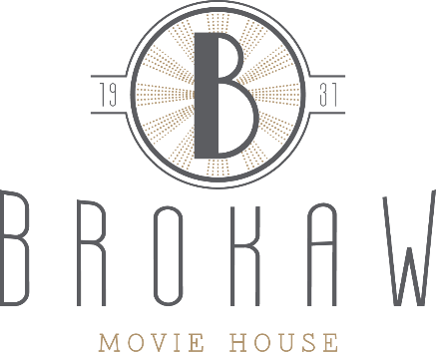

Rocky Horror Picture Show
Rules for Audience Participation

We want the Rocky Horror Picture Show to be a fun, safe, and respectful experience for everyone. We encourage certain forms of audience participation that uphold these values, but prohibit other activities that could either harm the theater or other participants.

You are encouraged to dress in costume for the show and participate in the following activities:

Newspapers: When Brad and Janet are caught in the storm, Janet covers her head with a newspaper The "Plain Dealer". At this point, you should likewise cover your head.
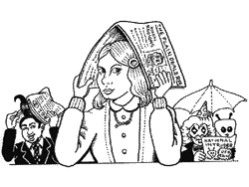

Flashlights or Cell Phones: During the "There's a light" verse of "Over at the Frankenstein Place, "you should light up the theater with flashlights or cell phones.
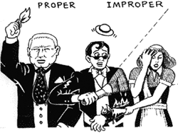

Rubber gloves: During and after the creation speech, Frank snaps his rubber gloves three times. Later, Magenta pulls these gloves off his hands. You should snap your gloves in sync each time to create a fantastic sound effect.
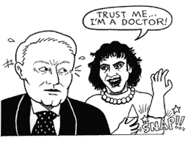

Noisemakers: At the end of the creation speech, the Transylvanians respond with applause and noisemakers. You should do the same.
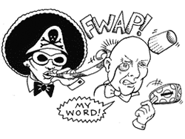

Party hat: At the dinner table, when Frank puts on a party hat, you should do the same.
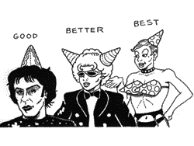

Bell: During the song "Planet Schmanet Janet," ring the bell when Frank sings "Did you hear a bell ring?"
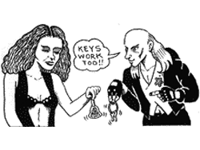

You will be removed from the theater if you do not adhere to the following rules:
No throwing objects at each other or the screen, including:
- No rice, confetti, toilet paper, toast / bread, playing cards, hot dogs, prunes, etc.
- Don’t throw anything.
No squirting or showering of any kind, including:
- No water guns, squirt guns, spitting water, etc.
- Don’t squirt water or any other type of liquid.
No open flames of any kind, including:
- No lighters, candles, matches, etc.
- Nothing lit on fire, this is an extreme safety hazard

